CONFLUENCE 2013 – A GLOBAL PANORAMA
Theme: Environment- a global concern

LIST OF EVENTS

 | i) | 8.00 to 8:30 am |  | Registration
 | ii) | 8:30-9:30 am |  | Inauguration Ceremony
 | iii) | 10:00 am to 1:00 pm |  | Competitions
 | iv) | 1:00 pm to 2:00 pm |  | Valedictory Function
Competitions |  |  | Grade |  | Venue | Theme
- Symphony  (Piano Competition) |  |  | Junior – I to V  Senior – VI to XI |  | Piano Lab | Peace
- Flight of Fantasy  (Fancy dress competition) |  |  | LKG, UKG |  | Basement Hall | Nature
- War on waste |  |  | I – II |  | Art Studio | Best out of waste
- Orator of the day  (Declamation competition) |  |  | III – V |  | Basement Hall | Science and Environment
- Techchamps |  |  | III – V |  | Jr. Computer Lab | Gaming
- Ad Zapper  (Ad designing competition) |  |  | VI – VIII |  | Dance Studio | Eco Friendly Product
- Robo War |  |  | VI – VIII |  | Robotics Lab | Navigation with Robo Crane
- Choreo Show Down  (Group Dance) |  |  | VI – X |  | Stage | Elements of Nature
- Digiwitz  (Website designing competition) |  |  | IX – XI |  | Sr. Computer Lab | Eco Club of School
- Fashion Mantra  (Dress designing) |  |  | IX – XI |  | Instrumental Studio | Dress with a Difference
- Hum Badlav Layenge  (Dramatics) |  |  | IX – XI |  | Stage | Comic Satire on social / environmental or political issues.

General Rules

- Last date of sending the entries is Ist May 2013, through post, e-mail or by personally dropping the registration form at school reception.

- All the participants and teachers should report at the school Registration counter by 8:00 a.m. on 9 May 2013.

- To ensure a fair competition, Participants should not give any reference to the name of their school.

- Participants should come in the school uniform wherever they are not required to be dressed up in any other costume.

- The rules specified for a particular event should be followed strictly.

- We would appreciate use of eco friendly props for all events.

- A participant is permitted to take part in one event only.

- Participation certificates will be given to all the participants & the three best entries of each event will be awarded.
- The school may send a maximum of 3 teachers (1 from senior department and 2 from primary) along with the participants.
- Experts from various fields will be invited to judge the events.

- The judgment of the Judges will be final and binding.

- The submitted entries will be the property of the host school.

- For any further query of information please contact school reception.

Sachdeva Global School
Sec 18a, Dwarka, New Delhi 10075
Ph: 011 - 28033005, 28032150, 28032828
45694307, 45694308 , Email: info@sachdevaglobal.in
Web: www.SachdevaGlobal.in

CONFLUENCE 2013 – A GLOBAL PANORAMA

EVENT DETAILS OF Piano Competition

GROUP – Junior (Classes I – V)
Senior (Classes VI – XI)
Theme – Peace

Time allotted: 1-3 mins.
No of Participants: One student from each group

Rules:
- Participants can play Indian or Western songs.
- Film songs are not allowed
- Piano will be provided by the school.
- Participants should play without accompaniment in proper piano style.

Judgement Criteria:

Rhythm, expressions, ambidexterity (capable of using both hands while playing)

CONFLUENCE 2013 – A GLOBAL PANORAMA

EVENT DETAILS OF Flight of Fantasy – Fancy Dress Competition
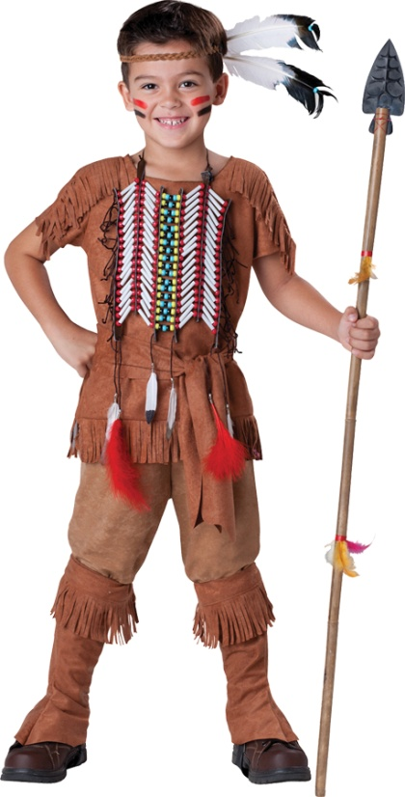
CLASSES: Pre-School to Pre-Primary
Theme – Nature

Time allotted: 1-2 mins. (Including entry and exit)
No of Participants: One each from LKG & UKG

Rules:
      - Participant should dress himself/herself to depict ‘Nature’
      - Enactment on the theme shall be given extra weightage.
      - No recorded aids will be allowed.
      - Kindly arrange props which can be handled by the participant himself/herself.
      - Contact Person : Ms. Ritu Bhatia - 9999264273

Judgement Criteria:

Costume, theme depiction, enactment, confidence, stage presence

CONFLUENCE 2013 – A GLOBAL PANORAMA

EVENT DETAILS OF “War on Waste”
CLASSES: I - II
Theme – Best out of waste

Time allotted: One and half hour
No. of participants: one team of 2 members.

Rules:

- Only one entry from each school is allowed
- Teams can make things using the following materials: -
Waste Cartons, newspapers, magazines papers, buttons, bangles, plastic bottles, wool, ice-cream sticks etc.
- Students have to bring their own material.

Contact Person – Ms. Preeti -8860111188

Judgement Criteria:
Creativity, No. of waste materials used, presentation and utility of the product made.

CONFLUENCE 2013 – A GLOBAL PANORAMA

EVENT DETAILS OF ORATOR OF THE DAY – Declamation Competition

CLASSES: III – V

Topic – ‘DOES THE ACCOMPLISHMENT OF SCIENCE JUSTIFY THE DAMAGE CAUSED TO NATURE?’

Time allotted: 2-3 Minutes
No. of participants: One

Rules:

- Only one entry per school is allowed.
- Language used should be English.
- Controversial / Negative and unparliamentarily language strictly prohibited..
- No reference to the name of school should be made during the competition.

Contact Person : Ms. Khushboo Kapoor – 9899329893

Judgement Criteria:
Confidence, Content, Pronunciation and Conviction

CONFLUENCE 2013 – A GLOBAL PANORAMA

EVENT DETAILS OF TECHCHAMPS – Gaming

CLASSES: III - V
No. of participant: One

Rules:

- Host school will be providing necessary hardware & software.
- Use of external hard drives, pen drives & CDs
is prohibited.

Contact Person – Ms. Jaity - 9013537830

CONFLUENCE 2013 – A GLOBAL PANORAMA

EVENT DETAILS OF AD ZAPPER – Designing an AD

CLASSES: VI – VIII

Children will Design and paint an advertisement with a tag line.
Theme: Eco friendly Product of daily use.
Time allotted: 1hour
No. of participants: Team of 2 students

Rules:
- Only one entry per school is allowed.
- A3 size ivory sheet will be provided by the host school.
- All the material required for designing, painting or decorating should be brought by the participants.
- Language can be English / Hindi
- Controversial / Negative and unparliamentarily language strictly prohibited.
- Ad should be completely original and creative.

Contact Person : Ms. Khushboo Bhutani - 9711545158

Judgement Criteria:
Originality, effectiveness of the ad, catchy slogan, neatness of presentation

CONFLUENCE 2013 – A GLOBAL PANORAMA

EVENT DETAILS OF - Robo War

CLASSES: VI – VIII
Problem Statement (Navigation with Robo Crane)
Problem Statement: To build a wired robot to lift & drop boxes into the basket.
Problem Description: The objective of the robot is to lift boxes from the arena and drop successfully into the basket through the Goal area in the minimum time possible.

Arena
1. The length & width of the arena is 8 feet x 8 feet.
2. The boxes used would be simple 4X4X4 inches Cubical boxes (total-15 boxes)
3. The Arena would be placed on the floor or 5-inches height from the floor.
4. The robot will start the race from the Start position of the arena.
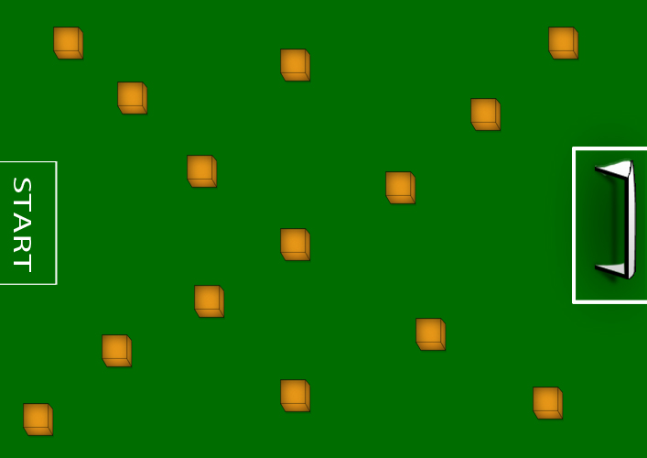

Rules -

Robot Designing

- One team has to design 1-robot that can lift boxes from the arena & drop them completely into the basket.
- The robots design should be controlled by a wired remote control.
- A power supply of maximum 12 Volts and 1 Amp can be used.
- The robot cannot weigh more than 5 kg.
- Any design that causes any harm to the arena would be liable for disqualification.
- The robot design cannot use or involve any sorts of combustible/harmful/dangerous parts in it.
- Each team will consist of maximum 4 members & 1 robot.
- There are total 15-boxes in the arena.
- Lego kits are not allowed.

Arena Run

- The duration of the run will be 7 minutes.
- The robot shall be placed at the starting point of the arena
- Each "Box dropped into basket through the goal area wins you points (10)”
- Each "Box dropped outside the basket results of loosing points (5)”

Scoring

- The timer starts as soon as the judges give their signal.
- The robot gets 1 minute of trial run before the arena run.
- The robots get maximum 7 minutes to lift & drop boxes into the basket during the arena run.
- The score for the arena run is calculated as follows:

Action | Score Generated
Dropping each box into the basket completely | + 10
Not dropping any box into the basket within 7 minutes | 0
Dropping each box out of the basket | -5

- The total score S for a robot that completes the 7 minute of arena run would be
calculated as follows:

S= (T*10) -(F*5) + DS
Where,
S is the total score after the arena run.
T is the total no. of boxes dropped into the basket completely.
F is the total no. of boxes dropped outside the basket.
DS is the design & presentation score that the judges give to the team.

- In case of tie, the decision of the judges will be final on the bases of team performance & design

CONFLUENCE 2013 – A GLOBAL PANORAMA

EVENT DETAILS OF CHOREO SHOW DOWN – Best Dancing Team

CLASSES: VI - X
Theme – Elements of Nature

Time allotted: 3-5 Minutes per team including entry and exit.
No. of participants: 8-10

Rules:
  - Only one entry per school is allowed.
  - Only semi classical / Indian Contemporary dance form is allowed.
  - Film songs or remixes are not allowed.
  - Props and accessories should be strictly as per the dance form.
  - Participating school should bring its own recorded music in CD’s only. Recorded music should be properly labeled.
  - Participants should be dressed in appropriate costumes in accordance with the theme and dance form.

Contact Person – Ms. Shiny Gulati - 9910093185

Judgement Criteria:
Choreography, Theme depiction, Synchronization, Costume, Use of props and Selection of Music.

CONFLUENCE 2013 – A GLOBAL PANORAMA

EVENT DETAILS OF DIGIWITZ – Website Designing Competition

CLASSES: IX - XI
Theme – Eco Club of school

Time allotted: one hour
No. of participants: One team of 2 students

Rules:
- The webpage has to be designed using HTML.
- A team will be given one hour to design the homepage with at least two links.
- Each team will be given 5 minutes to present the web page to the Judges using smart board.
- Host school will be providing the necessary hardware, software and images folder.
- Use of external pen drives and CDs is prohibited. If found in their possession, participants will be disqualified.

Contact Person – Ms. Jaity - 9013537830

Judgement Criteria:

Creativity, Colours, Pattern, Text and Animation.

CONFLUENCE 2013 – A GLOBAL PANORAMA

EVENT DETAILS OF FASHION MANTRA – Dress Designing Competition

CLASSES: IX - XI
Theme – Dress with a Difference

Time allotted: one and a half hour
No. of participants: One team of 3 students

Rules:
  - Each team to design one dress out of the materials which can be reused or recycled like old newspaper / magazine papers, broken bangles, used plastics, old buttons / ribbons etc.
  - Participating team should carry their own material for designing, painting or decorating.
  - One participant of each group will model the dress on stage for 1 minute on recorded music provided by the host school.

Contact Person – Ms. Shubham - 9899131171

Judgement Criteria:

Costume, originality, creativity, presentation, confidence, stage presence

CONFLUENCE 2013 – A GLOBAL PANORAMA

EVENT DETAILS OF “HUM BADLAV LAYENGE”

CLASSES: IX-XI
Theme – Comic satire on any current environmental, social or political issue.

Time allotted: 08 minutes
No. of participants: One team of 6 to 8 students

Rules:
- Language: bilingual
- No derogatory, racial, sexist or unparliamentarily language to be used.
- Only basic stage setting is allowed and stress should be on the enactment of the issue.
- Host School should be notified of any requirement that the team might have, at the time of registration.
- Participants should be dressed appropriately as per the theme taken up.
Contact Person – Ms. Shivangini -9868032900

Judgement Criteria:
Group coordination, acting skills, theme/issue presentation, confidence, comic element.

CONFLUENCE 2013 – A GLOBAL PANORAMA
Registration Form

School Name __________________________________________________________

Address ______________________________________________________________
______________________________________________________________
Phone No _________________________ Email-Id _____________________

Total No. of Participants _________ No. of accompanying teachers____

Name of the Event | Name of Participants | Class
- Symphony  (Piano Competition) | 1.  2.
- Flight of Fantasy  (Fancy dress competition) | 1.  2.
- War on waste | 1.  2.
- Orator of the day  (Declamation competition) | 1.
- Techchamps  (Gaming) | 1.
- Ad Zapper  (Ad designing competition) | 1.  2.
- Robo War  (Robotics) | 1.  2.
- Choreo Show Down  (Group Dance) | 1.  2.  3.  4.  5.  6.  7.  8.
- Digiwitz  (Website designing competition) | 1.  2.
- Fashion Mantra  (Dress designing) | 1.  2.  3.
- Hum Badlav Layenge  (Dramatics) | 1.  2.  3.  4.  5.  6.

Name of accompanying teachers - Junior Department ___________________
Senior Department____________________

Sign and seal of Principal

